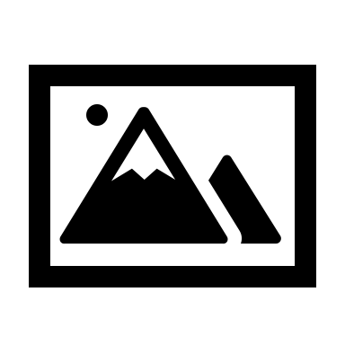

Replace with your logo

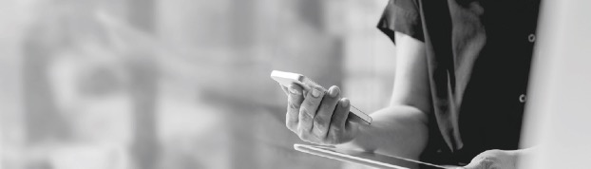

|  |
| --- |
| NOW MAKE YOUR  PAYMENTS WITH CASH |
| **AT OVER 40,000 MONEYGRAM LOCATIONS NATIONWIDE** |

Get started online at Your ClickPay URL or follow the steps below:

1. Bring this flyer with you to your nearest MoneyGram location. To find your closest MoneyGram, visit **www.MoneyGram.com.**
2. Locate the MoneyGram kiosk*, select “Payments”, and fill out the transaction details using the following information provided to you by your property manager:

**Account Number: ____________________**

**Receive Code:** 16459

**Company Name:** ClickPay

1. Visit the store cashier and request to “pay your bill.” Give your name and payment to the associate to complete the transaction.

|  |  |  |
| --- | --- | --- |
| **Convenient**  **Locations** | **Secure**  **Payments** | **No Stamps or**  **Money Orders** |
|  |  |  |

**Need Help?** Visit ClickPay's online support center at [**www.ClickPay.com/Help**.](http://www.ClickPay.com/Help)

*\*If your location does not have a kiosk, look for the red phone or request a MoneyGram form from the store cashier.*

*Please note that a small fee applies to cash payments made through MoneyGram.*